KARNATAKA VETERINARY ANIMAL AND FISHERIES SCIENCES UNIVERSITY, BIDAR

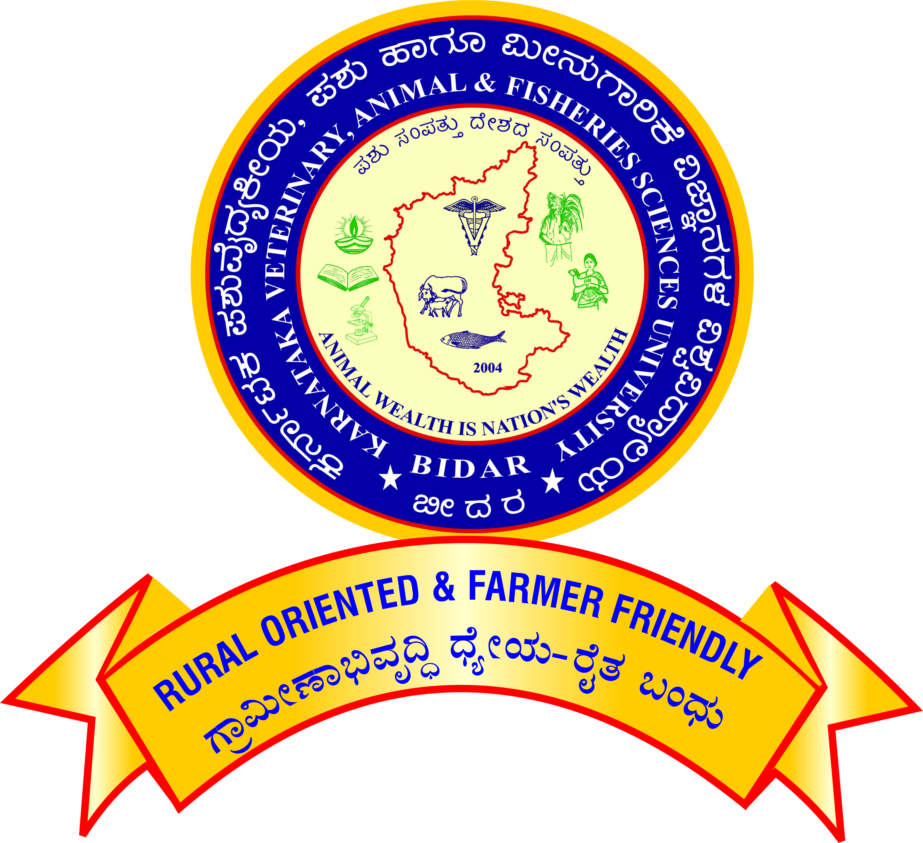

APPLICATION FOR PROMOTION OF TEACHERS UNDER CAREER ADVANCEMENT SCHEME – 2016

For promotion from Associate Professor (Academic Level 13A) to Professor (Academic Level 14)

[Note: All the claims shall be supported by relevant letters/certificates issued by concerned dean/controlling officer]

Affix self-attested photo

1. Name :

2. Designation and Address :

3. Name of the Department/ :

Section/Unit/Scheme

4. Date of Birth :

5. Academic Qualification :

|  |  |  |  |  |  |
| --- | --- | --- | --- | --- | --- |
| **Degree / Diploma** | **Discipline/**  **Subject** | **University/ Board** | **Month/**  **Year of passing** | **Marks/ OGPA**  **obtained** | **Remarks** |
|  |  |  |  |  |  |

6. Date on which Ph.D. degree Completed :

7.

|  |  |
| --- | --- |
| 1. Date of joining duty at KVAFSU, BIDAR as Assistant Professor in the Academic Level 12/AGP 8000 | : |
| 1. Date of joining duty at KVAFSU, BIDAR as Associate Professor in the Academic Level 13A/AGP 9000 | : |

8. Date of completion of 3 years’ service :

in the cadre of Associate Professor

(Academic Level 13A/AGP 9000)

**9. Employment record:**

1. Service within the university

|  |  |  |  |  |  |
| --- | --- | --- | --- | --- | --- |
| Place of work with full address | Designation / Post held | Scale of Pay | Period | | Nature of duties |
| From | To |
|  |  |  |  |  |  |

b. Service outside the university

|  |  |  |  |  |  |
| --- | --- | --- | --- | --- | --- |
| Place of work with full address | Designation / Post held | Scale of Pay | Period | | Nature of duties |
| From | To |
|  |  |  |  |  |  |

**10.** **Eligibility for Promotion**

1. Have you published a minimum of ten publications in the peer-reviewed journals or ICAR/UGC-listed journals, out of which three research papers have been published during the assessment period?  **Yes/No**

If yes furnish details as follows and enclose copy of the same

|  |  |  |  |  |
| --- | --- | --- | --- | --- |
| **Sr. No.** | **Authors** | **Title of the publication** | **Year** | **Volume and page numbers** |
|  |  |  |  |  |

1. Have you guided as Chairman / Member for at least one Ph.D candidate/Master’s degree candidate **OR** published three research or review article within first three authors other than publication required during assessment period? **Yes/No**

**If yes furnish the details**

## 11. Details of Work Performance:

## Areas in which the scientist/teacher made some mark including the specific Achievements in teaching/ research/Extension/corporate activities (administration and management) during the assessment period.

**A) Teaching:**

**ai. Courses taught**

**i) Bachelor level:**

|  |  |  |  |  |  |
| --- | --- | --- | --- | --- | --- |
| **Course title** | **Year & Class** | **Course No.** | **Cr.Hrs.** | **Semester** | **Independently or Jointly with** |
| Academic Year: | | | | | |
|  |  |  |  |  |  |

ii) **Master level:**

|  |  |  |  |  |  |
| --- | --- | --- | --- | --- | --- |
| **Course title** | **Year & Class** | **Course No.** | **Cr.hr** | **Semester** | **Independently or Jointly with** |
| Academic Year: | | | | | |
|  |  |  |  |  |  |

### iii) **Ph.D. level**:

|  |  |  |  |  |  |
| --- | --- | --- | --- | --- | --- |
| **Course title** | **Year & Class** | **Course No.** | **Cr.hr** | **Semester** | **Independently or Jointly with** |
| Academic Year: | | | | | |
|  |  |  |  |  |  |

iv). **Diploma courses**:

|  |  |  |  |  |  |
| --- | --- | --- | --- | --- | --- |
| **Course title** | **Year & Class** | **Course No.** | **Cr.hr** | **Semester** | **Independently or Jointly with** |
| Academic Year: | | | | | |
|  |  |  |  |  |  |

aii) Experiential Learning Course, HOT/RAWE/Industrial training/ Entrepreneurship:

b). Guidance to PG students as Chairman of the Advisory Committee

1. Completed Masters Students :
2. Completed Ph. D. Students :

**c). Guidance to PG students as Member of the Advisory Committee**

1. Completed Masters Students :
2. Completed Ph. D. Students :

**d).** **Teaching Aids developed** (manuals/ :

laboratory manuals, READY manuals/

Internship/Industrial training manuals).

B). Research:

1. Externally funded projects

|  |  |  |  |  |  |  |
| --- | --- | --- | --- | --- | --- | --- |
| **Sl.**  **No** | **Title** | **Funding agency** | **Budget** | **Year of start** | **Year of completion** | **As PI /Co-PI** |
|  |  |  |  |  |  |  |

**Note:** The Project shall be completed/in operation and Funds must be released.

1. **Patents / varieties / prototypes / technologies developed / breeder quality seeds production**

i) As PI :

ii) As Co-PI :

1. **Monitoring of the research/extension projects such as RKVY and other GoI/GoK Projects (Other than Externally Funded Projects).**

|  |  |  |  |  |  |  |
| --- | --- | --- | --- | --- | --- | --- |
| **Sl.**  **No** | **Title** | **Funding agency** | **Budget** | **Year of start** | **Year of completion** | **Involved as** |
|  |  |  |  |  |  |  |

1. Guiding project works of 1 month and above:
2. i) Head/Farm Superintendent in Research & Information Centers/Vaccine/Antigen production units/Disease investigation Section. :

ii) Working in the research & Information :

Centers as Scientist/Teacher

1. Internal Revenue Generation (Applicable only for LRIC/FRIC/RRDL to be certified by Director of Research) :

**C) Extension:**

1. Transfer of technologies (farm trails/ :

Field days/ Krishi Melas/ Demonstrations/

Exhibition/ Discussion meeting/ on-farm

Testing/ on campus official consultancy conducted

1. Training programme organized:

* Duration: upto 1 week

i) As Coordinator :

ii) As Associate Coordinator :

|  |  |  |  |  |  |
| --- | --- | --- | --- | --- | --- |
| **Sl No** | **Title** | **Duration** | **Place and Date** | **Organized by** | **Coordinator/Associate Coordinator** |
|  |  |  |  |  |  |
|  |  |  |  |  |  |

* Duration: more than one week:

i) As Coordinator :

ii) As Associate Coordinator :

|  |  |  |  |  |  |
| --- | --- | --- | --- | --- | --- |
| **Sl No** | **Title** | **Duration** | **Place and Date** | **Organized by** | **Coordinator/Associate Coordinator** |
|  |  |  |  |  |  |
|  |  |  |  |  |  |

1. As Resource Person in the training Programme :

Number of Lectures:

|  |  |  |  |  |  |
| --- | --- | --- | --- | --- | --- |
| **Sl No** | **Place and Date** | **Type of Event** | **Title of Training** | **Topic Discussed** | **Organized by** |
|  |  |  |  |  |  |
|  |  |  |  |  |  |

1. Official Diagnostic visit to farmer’sfields:

/On-farm/ Units/Radio/TV talk/Expert

Service/ Consulting/Visitors extension

1. Feedback to research/ Contribution to Package of practices
2. Clinics/ Diagnostic/ Farm Work/ Head:

of EEC/ (Other than teaching)

# Published work during the assessment period

1. **Research Publications:**

|  |  |  |  |  |  |
| --- | --- | --- | --- | --- | --- |
| **Sl**  **No** | **Name of Author(s)**  **in order** | **Year** | **Title of the paper** | **Name of the journal**  **(Vol. No., issue no & page no)** | **NAAS Rating** |
|  |  |  |  |  |  |

1. **Professional Book published/Edited (Minimum of 64 pages-Only with ISBN No.)**
2. Recognized publishers
3. Chapters in standard books
4. Research / Extension bulletin
5. Research note /communication in a journal / Presentation or abstract in symposium seminar / workshop / training manual /popular article / leaflet proceedings of the workshop

**III. Awards/Peer Recognition (During the assessment period)**

1. Awards from recognized International organizations like FAO, OIE/WoAH, WHO, IDF etc :
2. National awards by Govt. Institutions :
3. Recognized State awards / University awards :
4. Professional society award :
5. Other awards by registered organization :
6. Peer Recognition (Special assignments (International organizations, overseas and special national assignments / consultancies) :

**IV. Corporate Responsibilities / Other activities during the assessment period:**

**V. Outstation Service Details** :

|  |  |  |  |  |  |
| --- | --- | --- | --- | --- | --- |
| **Sr No.** | **Post held** | **Place of Work** | **Period of service** | | **Place/City Class (A/B/C)** |
| **From** | **To** |
|  |  |  |  |  |  |

**VI. Details of working in newly established colleges (W.e.f. 11-08-2018)**

|  |  |  |  |  |
| --- | --- | --- | --- | --- |
| **Sr No.** | **Post held** | **Place of Work** | **Period of service** | |
| **From** | **To** |
|  |  |  |  |  |

1. **Indicate three best contributions made (research /teaching / Extension/corporate activities (Administration and management) during the assessment period.**
2. **Any other significant achievement during the assessment period**

**(with documents)**

**Signature**

Verified that the information provided by the scientist/teacher is correct.

|  |  |
| --- | --- |
| Signature of the  Head of the Department | Signature of the  Controlling Officer |
|  |  |